**TABLEAU_ASSSIGNMENT**

**REPORTS**

**CALENDAR CHART:**

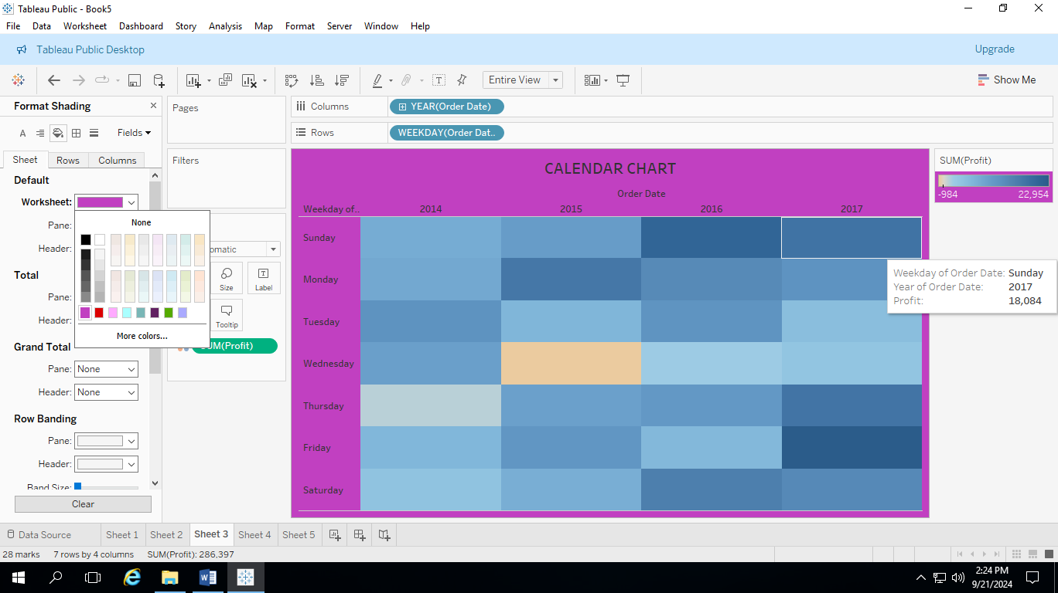

**WATERFALL CHART:**

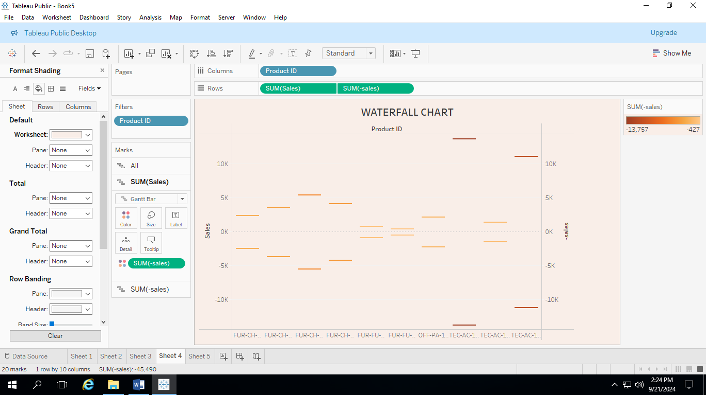

**DONUT CHART:**

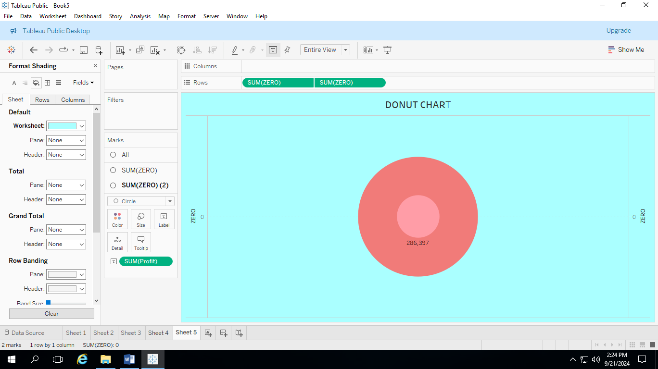

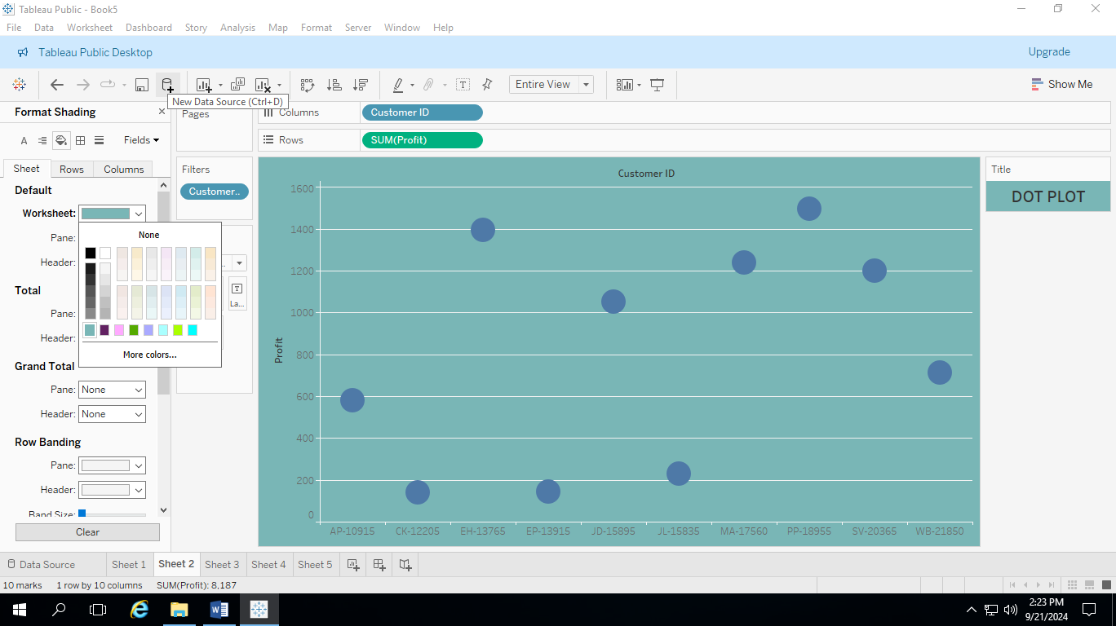**SCATTER PLOT:**